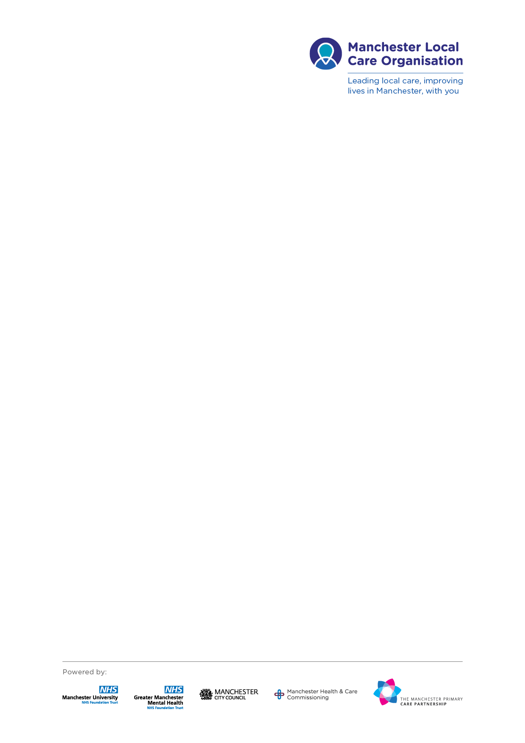

The Community **Adult** Learning Disability Service (CALDS) is a citywide service supporting adults over 18 with a ***learning disability*** (LD), where their health needs cannot be met by mainstream services, even after reasonable adjustments are made.

For someone to have a learning disability, **all three factors must be present**:

1. **Significant** difficulties understanding information or to learn new skills (***i.e. Significantly impaired intellectual functioning – IQ below 70***)
2. **Significant** difficulties coping independently (impaired adaptive functioning in at least 2 major domains e.g. independent living skills, self-care skills, etc)
3. Difficulties **must** have started in early childhood/before the age of 11 years old and had a pervasive effect on development.

Distinguishing between a ***learning disability*** and a ***learning difficulty*** is a complex issue. Learning disability only affects around 2% of the population and often gets confused with other conditions. It is not ADHD, brain injury (occurring post 18 years), dyscalculia, dyslexia, dyspraxia, autistic spectrum disorder (including Asperger syndrome), or a mental health issue.

**Factors that indicate the person *may* have a learning disability (LD):**

* **All three factors** above are present.
* Delayed development evident (key milestones e.g. speech, motor skills, social functioning) and difficulties with daily living before age 18.
* Difficulties across a number of areas of daily living not explainable by other difficulties (mental / physical health, substance abuse or social factors).
* Needs significant assistance for own survival (eating & drinking, personal hygiene, being warm & clothed, social adaptation, social problem solving).
* Evidence of additional, significant support needed to participate during education /placed at a special school/ had an EHCP
* Significant impairment of intellectual functioning such as having an IQ below 70.

**Factors that indicate the person is *not likely* to have a learning disability (LD):**

* Recorded IQ at or above 70.
* Normal development as a child. If difficulties do not present until the person is over 18, the person would not be considered to have LD.
* Previous diagnosis of Asperger’s or high functioning autism. (**NB.** Conditions such as Autism can co-exist with learning disabilities, but they alone do not mean that the person has a learning disability.)
* Needs are related to a diagnosis of dyslexia, dysgraphia, dyscalculia or dyspraxia.
* Successfully attended Mainstream education without support.
* Gained qualifications in education (e.g. GCSEs, NVQs)
* Able to live without support. Independent living skills are appropriate for age, context and physical health.
* Has independently sought and maintained paid employment for significant periods of time.
* Able to complete complex purchases e.g. buying a house.
* Able to drive a car.
* Engages with mainstream health & social care services without support.

**Community Learning Disability Teams in the Manchester city area:**

CALDS South - Etrop Court, Rowlandsway, Wythenshawe, M22 5RG 0161 219 6022

CALDS Central - Hulme District Office, 323 Stretford Road, M15 4UW 0161 219 2555

CALDS North - Crescent Bank, Humphrey Street, Crumpsall, M8 9JS 0161 861 2958