North Manchester Food Projects
Important: there are frequent changes to times / days / criteria of food projects. We cannot guarantee this information is up to date.
Please contact the project first to check information is current.

Name | Address | Contact details | Days & times | Drop in? | Referral  Yes / no | Other info
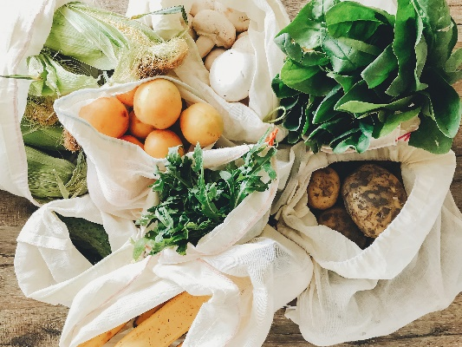  Christ the Vine  Church / The Vine  Sanctuary  Harpurhey | Park View  Rochdale Road  Manchester  M9 5TF | Tel: 07903 833949 | Every Wednesday  (please ring first)  12noon | yes | No | Arrive at 12noon and provide name and postcode. Free.
Bread and Butter Thing  Moston | Lily Lane Primary School  74- 84 Kenyon Lane  Moston M40 9LP | Text 07860063304 with name & postcode to arrange your first delivery. They will contact you to arrange the size & cost of bag you would like to collect. | Tuesdays  1.30pm – 2pm |  | No | £7.50
Community Pantry run by Lalley Centre  At St Malachy’s Church  Collyhurst | St Malachy’s Church Opposite the Lalley Centre  Eggington Street  Colly hurst  M40 7RG | 0161 205 2754 | Mon 2-4,  Weds 11-1  Fri 11-1pm |  | No | £3.50 for food and toiletries (first week free), also fresh food available from FareShare.
Nurturing Foundations  Food Bank | The Centre, Harpurhey Neighbourhood Project  Carisbrook Street  Harpurhey  M9 5UX | 077921 07226  0758 4493575  www.nurturingfoundations.org.uk | Every Other Thursday 5-7pm | Yes | No | £1
Rainbow Surprise  Crumpsall | Crumpsall Community Hall  Cleveland Road  M8 4GS | https://www.rainbowsurprise.com  hello@rainbowsurprise.com  075151 10208 | Monday, Tues, Thurs & Friday.  11am – 3pm | No | No | Collection only.
The Bread and Butter Thing  Harpurhey | Manchester Communications Academy, Silchester Drive M40 8NT | Text 07860 063 304 with your full name, postcode, and the name of the hub you will be collecting from. | Tuesdays  3.30pm – 4pm |  | No | Between £5 (smaller families) - £17 larger families)
The Bread and Butter Thing  Moston | 173 Kenyon Lane, Moston, Manchester M40 5HS | Text 07860 063 304 with your full name, postcode, and the name of the hub you will be collecting from | Tuesday 1:30pm- 2:00pm |  | No | Between £5 (smaller families) - £17 larger families)
The Bread & Butter Thing | Gateway  Church of the Saviour  Eggington Street,  Collyhurst, Manchester, M40 7SQ, | Text 07860 063 304 with your full name, postcode, and the name of the hub you will be collecting from | Monday 1:30pm-2:00pm |  | No | Between £5 (smaller families) - £17 larger families)
Mustard Tree  Ancoats | 110 Oldham Road  Ancoats  M4 6AG | Tel: 0161 850 2282 | Monday to Friday  10am – 2pm. | Yes | No | Food club £3 (10 items) Must register & be in receipt of benefits & must show proof

All above info correct on the 26/06/2024

