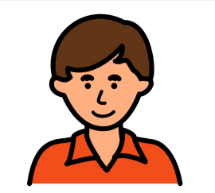

**My name is:**

Billy

I am 11 years old.

**Things I love:**

* Watching and talking about Buses and Trams, I also LOVE bus tickets.
* I love numbers and I am really good at remembering them.
* Food!
* I love my family.

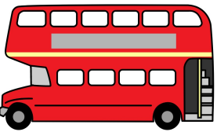

WHITE, Becky (MANCHESTER UNIVERSITY NHS 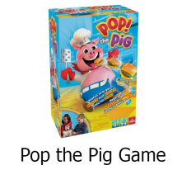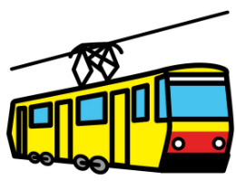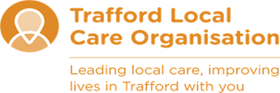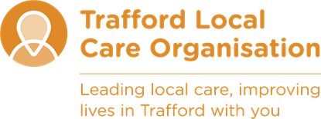

**Things people love about me:**

* I am funny.
* I have an amazing imagination.
* I love to have conversations with you.
* I have a great personality.

**How Best to Support me:**

* Use short simple phrases.
* Reduce your language if I become distressed.
* Play board games with me such as “Pop the Pig”.
* Take me out to watch the trams at the local water park.

**Things I don’t like:**

* Loud noises
* Rain
* Busy places/lots of people