**Name:**

**My person-centred**

**support plan**

Add picture of the Child

This plan is all about me. It describes me, what I need from my environment and how everyone can support me.

**What is the support plan for?**

The things I do happen for a reason. I might be letting people know that something is unsettling me, my needs are not being met, I am unhappy, or I am in pain. This plan can help people to understand what I might need.

A support plan is about working together with everyone around me so that I can feel good about myself and live my best life.

**Who has been involved in co-producing this plan?**   
(Please include your name and why you are part of my team)

**When was the last date that we reviewed this plan?**

**Plan version number:**

**Today’s date is:**

The professionals involved in my team should explain to me, as much as possible, what the plan is and how it might help. They should also explain who the plan would be shared with and how it would be used.

Permission is required from the people who are legally responsible for me, for the plan to be made and used.

**Consenting to the support plan**

This page is for the **lead practitioner** named on page 3 and my **legal guardians** to complete. Please cross [x] each box to confirm the statement.

**Lead practitioner confirmation:**

I have explained what a support plan is and how it will be used

I have explained who the plan will be shared with

**Legal guardian confirmation:**

The lead practitioner has explained to me what a Support Plan is and how it will be used

The lead practitioner has explained who the plan will be shared with

I have had the opportunity to ask any questions I have about the plan

I consent to this plan being made

**Lead practitioner signature and date:**

**Legal guardian signature and date:**

**Childs signature (where possible):**

**Child personal details**

Age and DOB

School

Who I live with? etc

**What I like**

Activities I like doing / things I like / sensory things I enjoy

**Getting to know me**

**Key things  
you need to know about me.**

**What I don’t like**

Activities I don’t like doing / things I don’t like / environments I don’t like.

How was I asked about these things?

**What are my strengths:**

**What makes me unique**

E.g., my identity/ culture/ heritage

**What am I good at:**

**What do people like about me:**

**Getting to know me**

**My Home**

Inner and Outer Circle of important people to me

Additional Information – specific to the child/young person

Eg:

My family are working on….

What do we do well as a family?

Capable environment Questionnaire – results of questionnaire

**My Health Needs**

My health needs are important to my wellbeing and other areas of my life. It is important that my health needs are understood by everyone supporting me and that I am able to access healthcare effectively.

You can find my hospital passport and/ or health action plan in **Appendix 1**.

My health needs are:

To be filled in with a health professional who knows me well (e.g., my school nurse)

**Managing Risks**

When I have found situations stressful or the environment has not met my needs, the environment may become even less capable by placing restrictions on me. Restrictions affect my quality of life because opportunities that I need are taken away from me.

Working together we looked at all the restrictions I have faced and tried to reduce them as much as possible. This is discussed carefully with the team around me who contributed to this plan. Sometimes it isn’t possible to reduce restrictions completely because of the need to keep me safe. When this happens, there must be a very clear reason for the restriction and how it is important for my safety.

**REWRITE**

You can find my safety plan in **Appendix 2**

|  |  |  |
| --- | --- | --- |
| **What is the risk?** |  |  |
| **What is my safety plan?** |  |  |

**My communication**

It is important that those around me know how to support my communication. Those around me can use my familiar tools and strategies when communicating with me. My way of communicating may be different to yours.

It can be very frustrating for me when communication breaks down. This is because I have less opportunity to make my choices and needs known. Good communication means that I know what is about to happen and we can understand each other better.

If you are an effective communication partner, I will understand you better and feel less frustrated.

**The formulation 5P’s:**

|  |  |
| --- | --- |
| **The 5P’s** |  |
| **Presenting Issues:**  *Details about the current problem. What are the symptoms?* |  |
| **Predisposing factors:**  *Pre-existing factors that may have contributed?* |  |
| **Precipitating factors:**  *What factors may have contributed to the onset of current problems? Why now?* |  |
| **Perpetuating factors:**  *What is keeping the problem going?* |  |
| **Protective factors:**  *What strengths/resources are already available?* |  |

**Behaviours of concern which you may see me display:**

**My communication**

BEHAVIOURS:

**What is this behaviour communicating?**

Here is a summary of themes from STARs.

**Setting:** what are the common setting events

**Action:** this is what happened

**Trigger:** what things were happening before

**Response**: This is what happened afterwards

Zarkowska, E., & Clements, J. (2018). *Problem behaviour and people with severe learning disabilities: The STAR approach*. Routledge.

**What am I communicating?**

What influences my well-being?

The things that happen around me may affect my feelings and how I communicate.

|  |  |
| --- | --- |
| *What might be going on inside my body that affects what you see e.g., I feel tired* | *What might be going on in the environment that affects what you see e.g., It’s too loud* |
|  |  |

Summary of suggested strategies to help me.

From looking carefully at my environment and understanding me, these strategies have been suggested :

Adapted from The Developing Mind (1999) book by Dan Siegel.



**What are we working on?**

**Goal:**

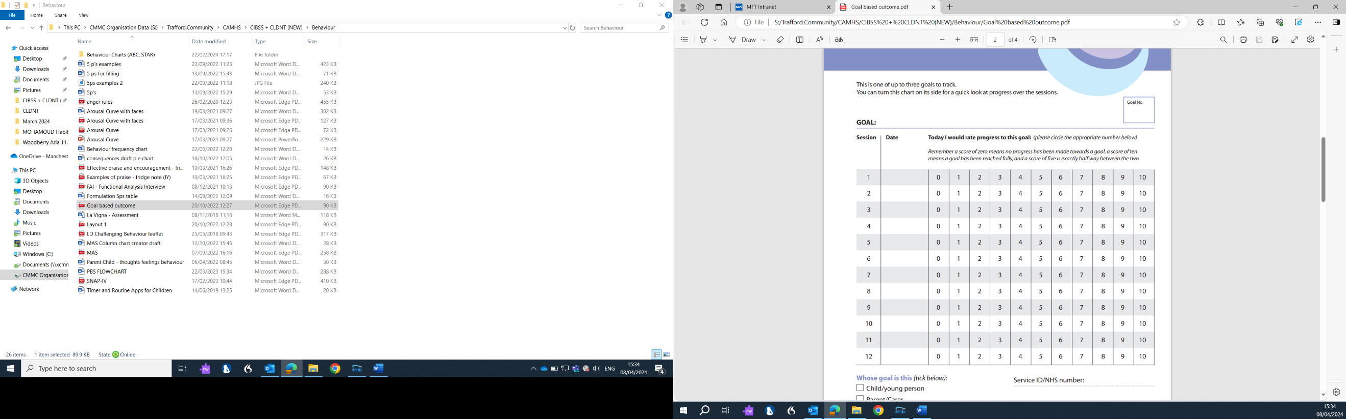

**What are we working on?**

**Goal:**



**Appendix**

1. My hospital Passport

2. My Safety plan