**You Are Now Entitled for Your Free NHS Bowel Health Check –**

**Do Not Ignore Your Invitation Letter and Home Test Kit**

Dear patient,

Your GP would like you to take part in the free NHS Bowel Screening Programme.

This is a free health test offered by the NHS for everyone in England who are aged from 52 to 74 years old (to include 50 year-olds from 2025).

Getting the test does not mean you are sick. It just checks to make sure things are okay.

People get the test while they are healthy, so that the Doctor can see any changes in their health before something serious happens. The test should be done every 2 years.

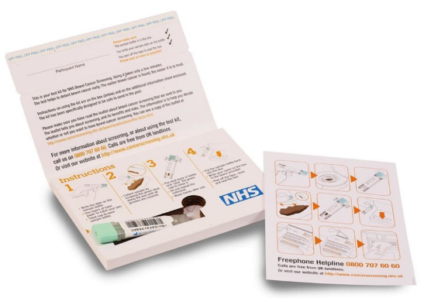You will receive an invitation letter and a test kit kit called a faecal immunochemical test (FIT). This will be sent to your home address by post. See pictures below on what the test kit looks like:

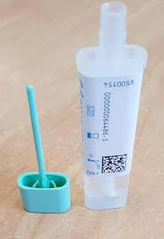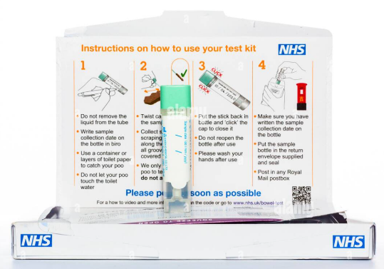

This test can help save your life – it is really easy, simple and hygienic to complete

If the test finds anything unusual, an appointment with a Nurse will be arranged for you and you may need to go to hospital to have further tests.

For more information such as when you will receive your home test kit, call the NHS Bowel Screening Hub using the free phone number **0800 707 6060** or email: [**bowelscreening@nhs.net**](mailto:bowelscreening@nhs.net) for more information or help.

If you are experiencing any problems with your tummy such as a change in bowel habit, blood in your poo, tummy pain or discomfort and/or weight loss. It is important that you make an appointment and speak to your GP.

It is really important to complete your home test kit as soon as you receive it.

Your sincerely

Dr X, X Medical Centre