Bowel Screening Non-Responder Guide l EMIS Web

Location of Searches:
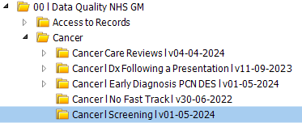

Once practices have accessed the folder highlighted above, this contains several searches for:

- Bowel Screening
- Breast Screening
- Cervical Screening

The Bowel Screening searches look like this:

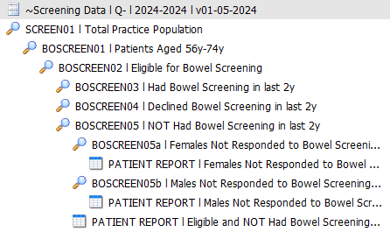

Non-Responder Searches
The following searches allow practices to identify patients who have not had bowel screening in the last 2 years and are also coded as not responded in the last 2 years, broken down by female and male:

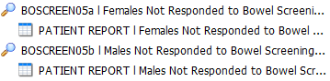

Patient Reports
The 2 patient reports include the following details to enable practices to contact patients:

Patient Details:
- EMIS Number
- Full Name
- Age
- Date of Birth
- Gender
- Mobile Telephone
- Home Telephone

Clinical Details:
- Latest Bowel Screening Results l Date & Code Term
- Latest Non-Responder Information in the last 2 years l Date & Code Term

SNOMED CT Codes
The following codes are included in the non-responder searches:

SNOMED CT | Description
1101401000000107 | No response to bowel cancer screening programme liquid faecal immunochemical testing invitation
373251000000108 | No response to bowel cancer screening programme invitation
884741000000108 | Bowel scope (flexible-sigmoidoscopy) screening invitation: did not respond

Data Quality Support
If you require any DQ advice in relation to the above, please contact the following email address: nhsgm.dataquality@nhs.net. The account is monitored daily.

