**TELEPHONE SCRIPT SUPPORT**

This telephone script should be used as a guide to ensure each vital point in the conversation is covered with the non-responder.

If you have any difficulties speaking to non-responders to the bowel screening programme, please call Johnson on 07881 541343 for support and guidance or email [johnson.liu@mft.nhs.uk](mailto:johnson.liu@mft.nhs.uk) or [johnson.liu1@nhs.net](mailto:johnson.liu1@nhs.net)

Alternatively, you can also contact the Bowel Screening Hub on 0800 707 6060.

Further information about the NHS Bowel Cancer Screening Programme, please see the following websites:

<http://www.cancerscreening.nhs.uk/bowel>

<http://www.bowelcanceruk.org.uk>

<https://www.nhs.uk/conditions/bowel-cancer/>

**Sample Telephone Script**

Recent studies have shown that having meaningful conversations with non-responders either by telephone or through face-to-face opportunities can help encourage and support patients to engage with bowel screening. The following diagram provides some suggestions for a conversation with non-responders.

**Receipt of bowel screening kit -** Can I just check if you have received your kit please, as your health records indicate that your kit has not been completed?

**Introduction -** Good morning/afternoon, can I speak to *[patient’s first name]* please?

Hi there, *[patient’s first name*] my name is X and I am calling you from your local GP.

There is nothing to worry about, I’m just calling with regards to your Bowel Cancer Screening kit that you recently received through the post.

NO

YES

Can I ask your reasons why you didn’t return the kit please? Record why on patient tracker spreadsheet.

Check if the address is correct?

Offer to order a replacement kit on their behalf (consent required)

Unsure whether to complete or not

Wants to participate but didn’t get round to it

Doesn’t want to participate

Order replacement kit for patient by completing Kit Request spreadsheet & send to Hub.

Update patient tracker spreadsheet.

Discuss reasons for and against screening

Patient will receive another kit in 2 years’ time.

To opt out, patient need to officially request by contacting the bowel screening centre on 0800 707 6060.

Suggest practical tips to complete the kit

Common issues: How to collect poo

**Benefits:**

Bowel screening saves lives from bowel cancer.

Test is for patients with no bowel symptoms.

Only 2 people out of 100 who complete the kit need a further test (colonoscopy).

Wishes to participate

Doesn’t want to participate

**Reasons against Screening**

|  |  |
| --- | --- |
| Reason | Information to provide |
| Language barriers | Offer to send patient engagement letter in preferred language (if available).  And/or:  Send the *‘How to use FIT bowel screening kit’* video to patient’s mobile phone. Send the following link with a short message:  <https://vimeo.com/showcase/6663813/> |
| Test is messy / I don’t know how to do it | Explain the current test (FIT) is now different to the old version (FoBT) and requires only one sample rather than the previous three. The test can be done at home. It’s a simple, quick and hygienic test that saves lives. Talk through steps on page 6.  There are clear instructions on the box of the screening kit on how to complete test kit.  Alternatively, send how to complete bowel screening video link to patient’s mobile phone: <https://vimeo.com/showcase/6663813>  Offer HUB number if necessary 0800 707 6060. |
| I don’t have any symptoms | The screening process is designed for those who do not have symptoms and feel well. The kit is not for people who have symptoms. |
| I’ve lost the kit | Offer to order patient a new one (complete spreadsheet for the Hub & seek consent from patient to share details). Check with patient that they know how to complete kit. |
| I don’t want to know if I have cancer | Show understanding to their response – yet let them know it is important that they make an informed decision and provide the following information:   * Each year around 2.5 million people complete the kit * **It is estimated 9/10 people diagnosed at the earliest stage will survive bowel cancer** * The longer a cancer goes untreated, the chances of survival decrease * If cancer cells are detected early enough, it may be possible to remove the cancerous cells during a colonoscopy. * **Screening could prevent the need for extensive treatment** |
| I am too embarrassed | It is perfectly natural and common to feel embarrassed about completing the screening kit. However, please be aware that discretion and the upmost confidentiality is at the forefront of the bowel screening programme and all staff are extremely well trained and qualified to professional support you. |
| I’ve already done the test | Make sure the test was in the last two years, if so, apologise and end the call.  If the test was longer than two years ago, explain this is another round of testing that happens every two years for those between the ages of 52-74 *(aged 50 from 2025 – tbc).* |
| I didn’t think it was that important / I never got around to it | Offer to talk patient through ‘More about Bowel Cancer’ section. |
| Fear of colonoscopy | Explain that it is ultimately the patient’s decision, but it is important they make an informed choice. Explain that patient experience of colonoscopies can be different and not to base their decision on other people’s experiences.  If a screening results comes back as abnormal you will be offered an appointment with a specialist screening nurse, this is the ideal time to ask questions and get as much information you need of the colonoscopy. |
| Negative perception of what a diagnosis of cancer could mean | If cancer cells are detected early enough, it may be possible to remove the cancerous cells during a colonoscopy. The later it is left the more difficult it is to treat. Screening aims to detect any abnormalities at its earliest stage. |
| I don’t need to do it, the blood found on the test will be from my haemorrhoids/other condition | If you do have conditions such as haemorrhoids, the blood found may be from this. However, we need to find out that the blood isn’t coming from anywhere else as well. |
| Concerns around Covid-19 | Trafford General Hospital is a Covid free hospital, so you could request your procedure to take place here.  The health, safety and wellbeing, of all our patients, communities and staff in the hospital and in the community remain our absolute priority. Because of the current COVID-19 pandemic we are taking extra steps to make sure you stay safe when you have an appointment with us.  This does mean we are doing things a little differently. We have social distancing steps in place around the hospital and other precautions that are helping to continue to limit the spread of COVID-19.  You will be given detailed instructions before attending your appointment so will know exactly what to do. |

**More about Bowel Cancer section**

**Incidence**

* Bowel cancer is the second biggest cancer killer in the UK claiming more than 16,000 lives a year, that's over 44 people every day
* Bowel cancer is the fourth most common cancer in the UK, after breast, prostate and lung cancers.
* 1 in 15 men and 1 in 18 women will be diagnosed with bowel cancer during their lifetime

**Screening**

* Bowel cancer is treatable and curable, especially if diagnosed early. **It is estimated 9/10 people diagnosed at the earliest stage will survive bowel cancer**. However, this drops significantly as the disease develops. Early diagnosis really does save lives
* **2400 deaths per year are avoided through screening**

### Benefits

* Taking part in bowel cancer screening lowers your risk of dying from bowel cancer
* Screening can find non-cancerous growths (polyps) in the bowel that may develop into cancer in the future. Removing these polyps can reduce your risk of getting bowel cancer

### Risks

* No screening test is 100% reliable. There's a chance a cancer could be missed, meaning you might be falsely reassured
* There are no risks to your health from the home testing kit

**In summary**

* Your doctor is very supportive of bowel screening and we are encouraging all our patients over the age of 60 to take part in screening. More than 9 out of 10 people with early stage bowel cancer will survive. Therefore, bowel screening is so important.

It is important to document the reasons why patients do not want to participate in screening to shape future service provision. If the opportunity arises, ask the patient what it would take for him/her to take up the screening offer and document this also.

3a) Add the patient to the FIT order form and ask them if they would like any information on competing the kit. Guide the patient through the following steps. If the patient needs support once the kit arrives (should be within 2 week) they can call the HUB on 0800 707 6060.

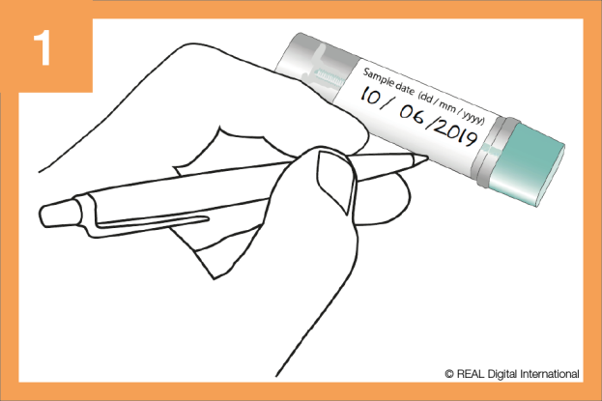

* Write the date on both the bottle and the sample bottle in biro
* Use a container or layers of toilet paper to catch your poo
* Do not let your poo touch the toilet water

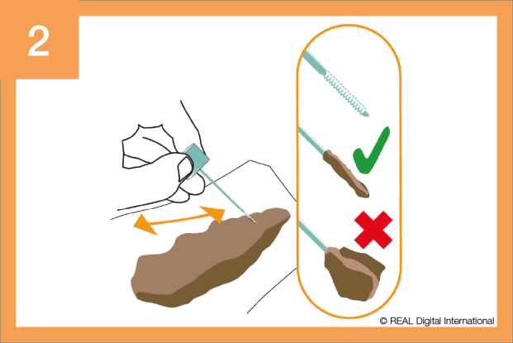

**Collecting the sample**

* Twist the cap to open the sample bottle
* Collect a sample by scraping the stick along the poo until all grooves are covered
* We only need a little poo to test. **Please do not add extra**

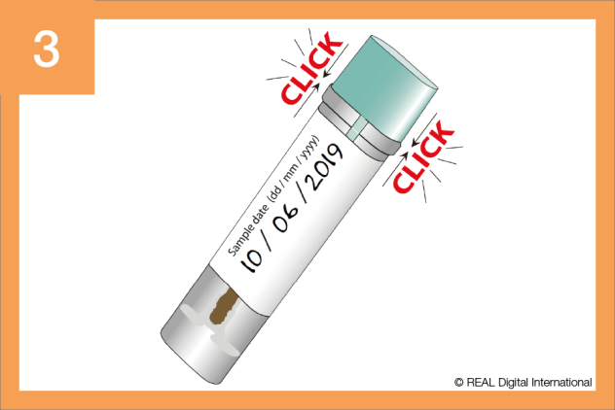

**Clicking the sample bottle shut**

* Put the stick back in the bottle and ‘click’ the cap to close it
* Do not reopen the bottle after use.
* Please wash your hands after use

**Preparing to post the completed kit**

* Make sure you have written the date on the sample bottle
* Put the sample bottle in the return envelope supplied
* Peel off the tape, and seal the envelope and post

Please post your completed kit as soon as possible.

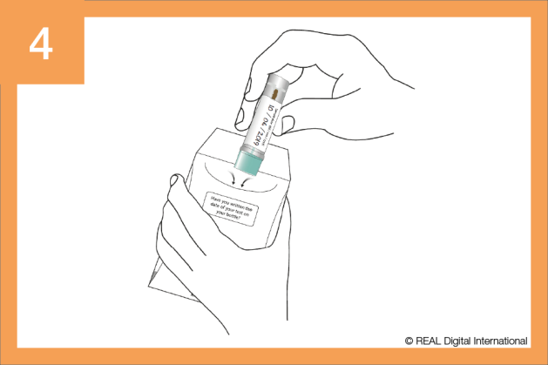

## Other questions that might arise during the conversation

1. **Where is the bowel? And what does it do?**

The large bowel is a long pipe in the digestive system just below the stomach.

It absorbs water and nutrients from food and passes waste out of the body as poo. The small bowel connects the large bowel and the stomach.

1. **What is bowel cancer?**

**Bowel cancer is also called colorectal cancer.** The cells in your body normally divide and grow in a controlled way. When cancer develops, the cells change and can grow in an uncontrolled way.

1. **Why is it so important to spot bowel cancer early?**

Most bowel cancers don’t kill us if they’re treated at an early stage. If cells are given time to spread to other parts of the body the chance of survival reduces significantly. That’s why spotting cancer early saves lives. More than 9 out of 10 people with bowel cancer will survive when it is found early.

1. **Why should I be screened for bowel cancer?**

Screening helps to detect bowel cancer early, even before you could notice symptoms. The risk of bowel cancer increases with age, and that’s why people aged 60 to 74 are sent a screening kit every two years. People over 75 can request a screening kit by calling **0800 707 60 60**.

1. **I have piles (haemorrhoids); does this mean blood in my poo won’t be caused by bowel cancer?**

People with haemorrhoids are as likely to get bowel cancer as anyone else. The blood could be due to several different reasons; going through the screening pathway can help to rule some of these out. If you see blood in your poo, even if you have haemorrhoids – always check with your GP.

1. **Can I reduce my chances of getting bowel cancer?**

Yes. Bowel cancer is a very common type of cancer and over half of cases are caused by risks that you can control including:

* A diet high in red or processed meats
* Being overweight: Those in the healthy weight range are less likely to develop bowel cancer than obese people
* Being inactive – we should aim for 150 minutes of moderate activity each week
* High alcohol intake – guidance shows we should not consume more than 14 units per week
* Smoking
* If you would like support with any of the above, please contact your local Health Promotion Team

1. **My parent/sibling had bowel cancer; does this affect my chances of getting it?**

A family history of bowel cancer (a close relative) can put you at greater risk of developing the disease. Screening can help you to understand what is going on in your bowel right now

This information is based on the ‘Get Greater Manchester Screening’ paper as part of the Greater Manchester Vanguard Programme.

**Non-responders**

* Typically surrounded by more ill health than responders
* As well as themselves, friends and family tend to have more health conditions which contribute to their knowledge and perceptions of what a cancer diagnosis would mean
* More experiences of the NHS including more negative experiences around wait times, delays, length of time from diagnosis to treatment
* Influenced by older family member’s negative experiences
* Feel that doing the test may lead to ill health and negative consequences

**Non-responders categorised**

59-62 years worried about ageing

* More likely to be men
* Reluctant to see relevance of test to themselves
* Strong negative emotions with ageing – linked with ill health
* Low belief of benefits
* Less well connected
* Lowest belief and knowledge of early detection.
* Give objections such as dealing with poo, but root cause is fear of ageing

**Advice**

* Provide information on early detection and what that could mean in comparison to detecting it at a later stage
* Test to prevent illness to stay young and active longer
* More acceptable not to mention cancer but more of a wellbeing test for bowel health

**59-62 years fearful of cancer**

* Strong negative emotions about cancer
* Low sense of control of own health
* Don’t want added worry of discovering cancer
* Low awareness of knowledge of benefits in early detection
* Associate test with cancer and therefore unpleasant treatment

**Advice**

* Screening be a quick and easy wellbeing test of the bowel to prevent life changing illness or need for excessive treatment. Allows you to get on with life
* Do not need time off work to do the test, do it at home. Small effort for a big benefit
* Provide information on benefits of early detection

**Older Pessimists (70+ years)**

* Repeat avoiders
* Beliefs are based on other negative experiences of cancer and do not see the point in doing it now
* Already use the NHS and do not want to burden it
* Believe cancer is inevitable and have low belief in prevention

**Advice**

* Advise it is a wellbeing test for the bowel that is recommended by their GP and the NHS, even later in life
* Can prevent life threatening illness which allows them to get on with their lives without fuss
* Where necessary give information on benefits of early detection

**South Asian and Pakistani population**

* Physical barriers such as: Do not know about the test, could not read the test, misunderstood the test and did not know who to ask for help
* Lower health literacy
* High negative beliefs around cancer treatment and outcomes – usually refer to a horror story
* Lack of awareness, education and advice that is said in the way

**Advice**

* Provide information on benefits of early detection and how this does not always involve treatment such as chemotherapy
* Provide information on incidence of bowel cancer seen in section 2b
* GP advising everyone in the community to take the test
* Free and easy

|  |  |
| --- | --- |
| **Do’s and Don’ts** | |
| **Do** | **Don’t** |
| Take the patient through security questions at the beginning of the call. | Give any medical advice, health advice or guidance outside of bowel screening. |
| Advise bowel screening is supported by their GP. | Try to persuade or pressure patients to take up screening |
| Each year around 2.5 million people complete the kit | Tell patients they must take part. |
| Show understanding and respect, particularly around patients’ decisions not to complete screening. | Discuss a patient’s details with someone that picks up the phone (spouse, family member, friend etc.) unless agreed by the patient. |
| Promote an informed decision. | Argue with a patient |
| Advise any medical issues must be discussed directly with GP. | Discuss patient information with anyone apart from appropriate practice staff, screening centre staff and regional hub staff. |
| Consider all information to be confidential unless told otherwise. |  |